Twitter test:

1.

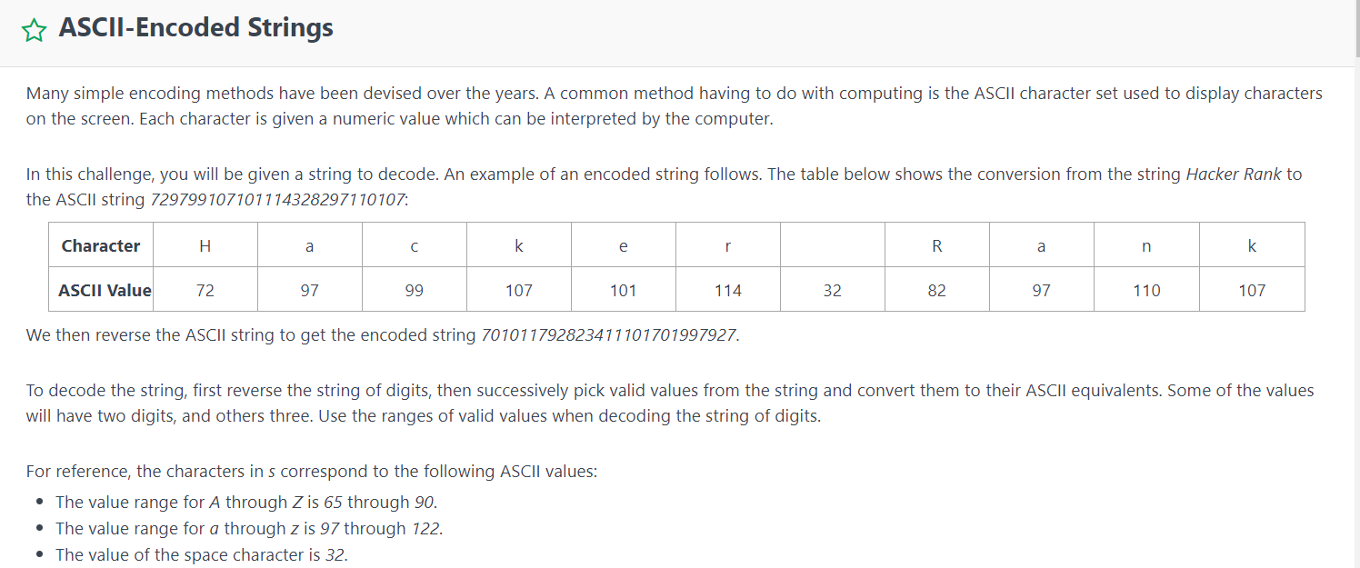

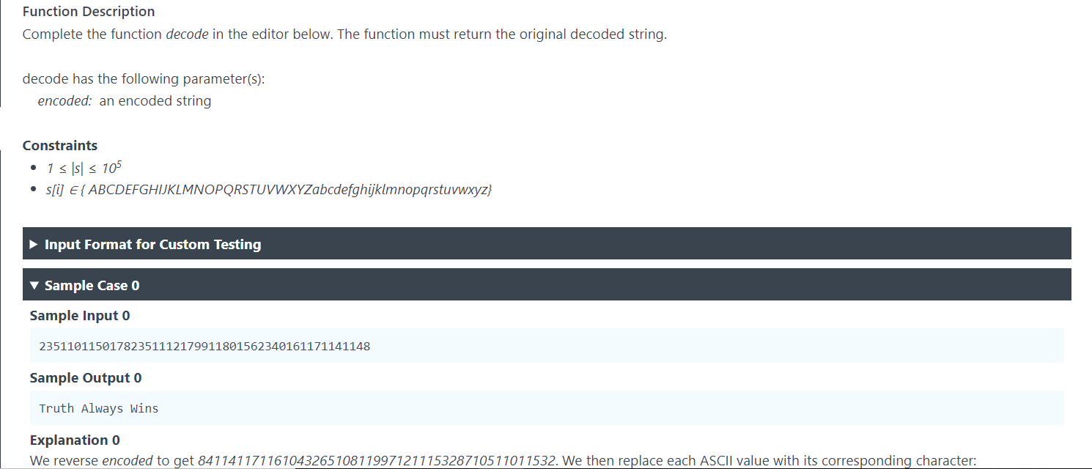

Solution:

// Complete the decode function below.

static String decode(String encoded) {

StringBuilder encodedSB=new StringBuilder();

StringBuilder result=new StringBuilder();

encodedSB.append(encoded);

encodedSB=encodedSB.reverse();

//System.out.println(Integer.parseInt(encoded)+5);

if(encodedSB.length()<3){

// System.out.println(Integer.parseInt(encoded)+5);

if(Integer.parseInt(encoded)!=32&&Integer.parseInt(encoded)<65||(Integer.parseInt(encoded)>90&&Integer.parseInt(encoded)<97)||Integer.parseInt(encoded)>122){

System.out.println(Integer.parseInt(encoded)+5);

return "";

}

else

return Character.toString((char)Integer.parseInt(encodedSB.toString()));

}

else{

int i=0,j=2;

int character=0;

while((i+j)<=encodedSB.length()){

character=Integer.parseInt(encodedSB.substring(i,i+j));

if(character>64&&character<91||character>96&&character<100||character==32){

result.append((char)character);

}

else if(character>9&&character<13){

if(i+j!=encodedSB.length()){

character=Integer.parseInt(String.valueOf(character)+Character.toString(encodedSB.charAt(i+j)));

if(character>99&&character<123)

result.append((char)character);

j=j+1;

}

else return "";

}

else

return "";

i=i+j;

j=2;

}

return result.toString();

}

}

2.

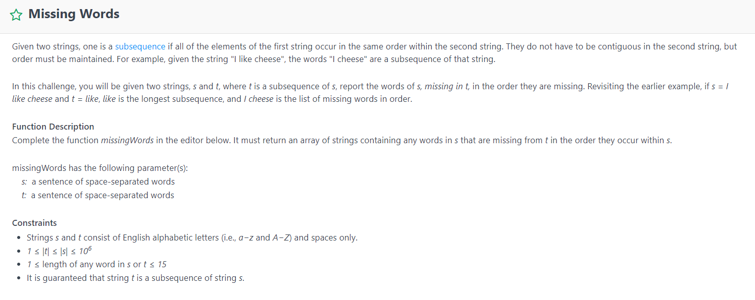

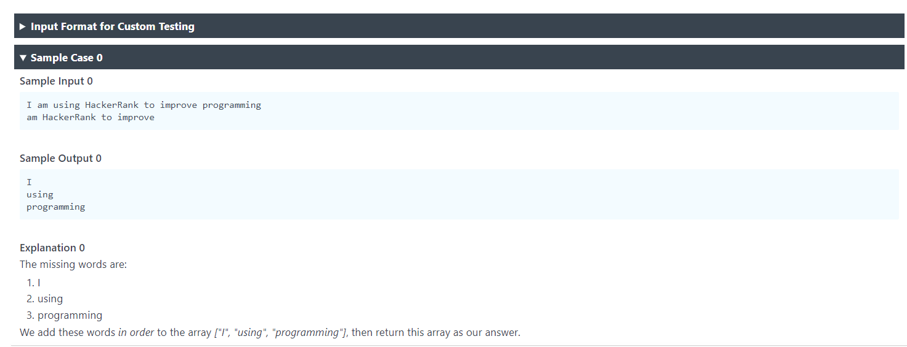

Solution:

class Result {

/*

* Complete the 'missingWords' function below.

*

* The function is expected to return a STRING_ARRAY.

* The function accepts following parameters:

* 1. STRING s

* 2. STRING t

*/

public static List<String> missingWords(String s, String t) {

// Write your code here

//Set<String> all_words=new

int from_index=0, index=0,i=0;

List<String> result= new ArrayList<String>();

String[] s_words=s.split(" ");

List<String> s_words_list=Arrays.asList(s_words);

int s_words_size=s_words_list.size();

if(t==null){

return s_words_list;

}

else{

String[] t_words= t.split(" ");

List<String> t_words_list=Arrays.asList(t_words);

int t_words_size=t_words_list.size();

while(i<t_words.length){

if(s_words_list.subList(from_index,s_words_size).contains(t_words_list.get(i))){

index=s_words_list.subList(from_index,s_words_size).indexOf(t_words_list.get(i));

result.addAll(result.size(),s_words_list.subList(from_index,from_index+index));

from_index=from_index+index+1;

i++;

}

else

return null;

}

result.addAll(result.size(),s_words_list.subList(from_index,s_words_size));

return result;

}

}

}

//System.out.println(t_words_list.get(i)+" found at index: "+s_words_list.subList(index,s_words_size).indexOf(t_words_list.get(i))+" in the subList: "+ s_words_list.subList(index,s_words_size));

//System.out.println("result from & to: previous: "+previous_index+" index: "+((index+previous_index)-1));

//System.out.println(result);

3.

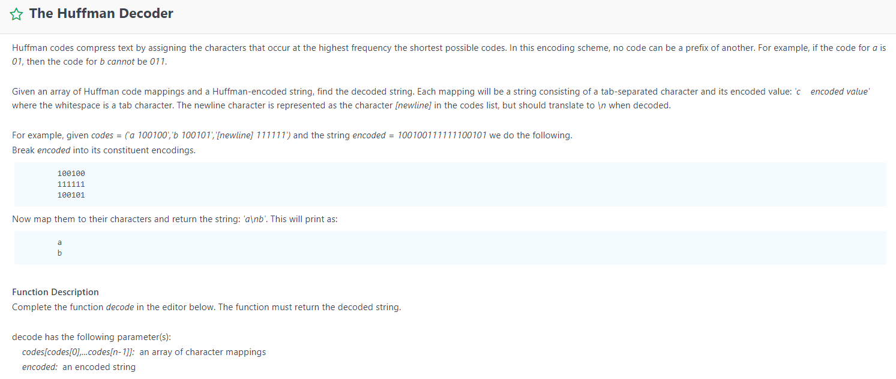

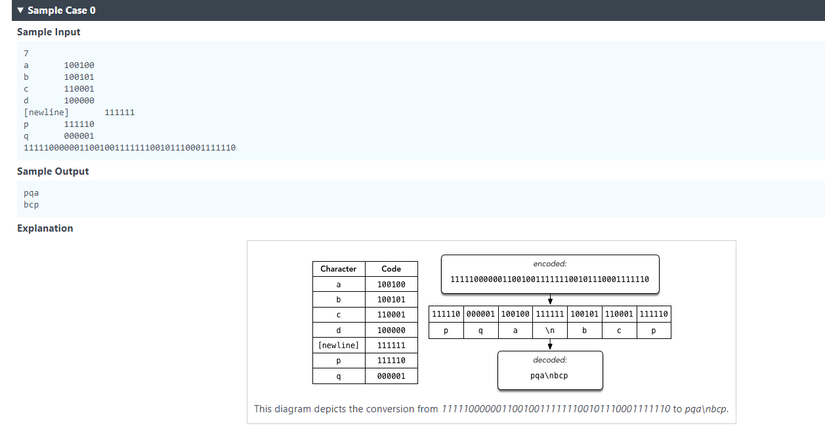

Solution:

// Complete the decode function below.

static String decode(List<String> codes, String encoded) {

int start_index=0;

List<String> code_value= new ArrayList<>();

List<String> letters= new ArrayList<>();

StringBuilder result=new StringBuilder();

for(int j=0;j<codes.size();j++){

String[] w=codes.get(j).split("\t");

code_value.add(w[1]);

letters.add(w[0]);

}

for(int i=1;i<=encoded.length();i++){

if(code_value.contains(encoded.substring(start_index,i))){

if(!letters.get(code_value.indexOf(encoded.substring(start_index,i))).equals("[newline]"))

result.append(letters.get(code_value.indexOf(encoded.substring(start_index,i))));

else

result.append("\n");

start_index=i;

}

}

return result.toString();

}